VFD Motor Controller

Mackenzie Miller

Andrew Nguyen

Aidan Rader

Ryan Regan

**Functional System Requirements**

REVISION – 1

28 April 2025

Functional System Requirements

for

VFD Motor Controller

Prepared by:

_____________________________

Author Date

Approved by:

_____________________________

Project Leader Date

_____________________________

John Lusher, P.E. Date

_____________________________

T/A Date

**Change Record**

|  |  |  |  |  |
| --- | --- | --- | --- | --- |
| **Rev.** | **Date** | **Originator** | **Approvals** | **Description** |
| **0** | 9/26/2024 | VFD Motor Controller Team |  | Draft Release |
| **1** | 12/5/2024 | VFD Motor Controller Team |  | Reference documents updated |
| **2** | 4/28/2025 | VFD Motor Controller Team |  | Final Report Update |

Table of Contents

Table of Contents III

List of Tables IV

List of Figures V

1. Introduction 1

1.1. Purpose and Scope 1

1.2. Responsibility and Change Authority 1

2. Applicable and Reference Documents 3

2.1 Applicable Documents 3

2.2 Reference Documents 3

2.3 Order of Precedence 3

3. Requirements 4

3.1 System Definition 4

3.2 Characteristics 5

3.2.1 Functional / Performance Requirements 5

3.2.2 Physical Characteristics 6

3.2.3 Electrical Characteristics 6

3.2.3.1 Inputs 6

3.2.3.2 Input Voltage Level 6

3.2.3.3 Input Noise and Ripple 6

3.2.3.4 External Commands 6

3.2.3.5 Visual Output 6

3.2.3.6 Connectors 7

3.2.3.7 Failure Propagation 7

3.2.3.8 Built in Test (BIT) 7

Appendix A: Acronyms and Abbreviations 10

Appendix B: Definition of Terms 11

List of Tables

*Table 1: Subsystem Designations* 2

*Table 2: Applicable Documents* 3

*Table 3: Reference Documents* 3

List of Figures

*Figure 1: Project Conceptual Image* 1

# Introduction

## Purpose and Scope

The VFD motor controller is intended to control the speed and torque of an AC motor by varying the frequency and voltage supplied. This project will use three phase power as the input that will be converted to DC and then transmitted to a microcontroller via optoelectronics and used to power a motor. The microcontroller also will send signals to the DC link, again using optoelectronics, that contain the desired frequency. The VFD motor controller will come with a user interface that allows the user to input the frequency needed and start or stop the system as needed. This VFD shall be implemented to increase efficiency and save energy.

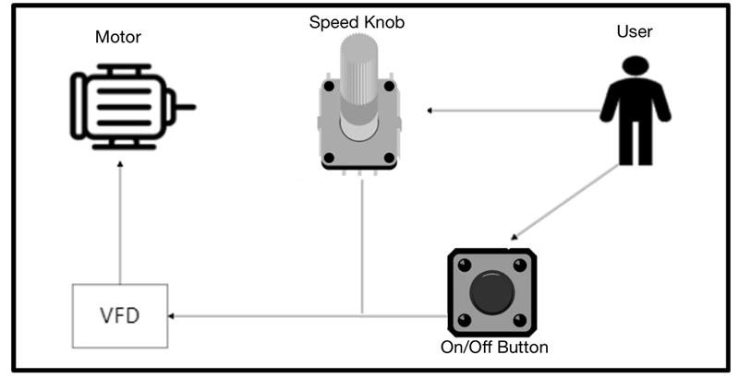

*Figure 1: Project Conceptual Image*

The following definitions differentiate between requirements and other statements.

Shall: This is the only verb used for the binding requirements.

Should/May: These verbs are used for stating non-mandatory goals.

Will: This verb is used for stating facts or declaration of purpose.

## Responsibility and Change Authority

Briefly describe who has the responsibility for making sure the requirements are met (i.e., team leader) and who has the authority to make the changes (i.e., client and team leader).

|  |  |
| --- | --- |
| **Subsystem** | **Team Member** |
| Optoelectronics & Monitoring | Mackenzie Miller |
| Microcontroller | Andrew Nguyen |
| Rectifier & DC Link | Aidan Rader |
| Firmware | Ryan Regan |

*Table 1: Subsystem Designations*

# Applicable and Reference Documents

## 2.1 Applicable Documents

The following documents, of the exact issue and revision shown, form a part of this specification to the extent specified herein:

|  |  |  |
| --- | --- | --- |
| **Document Number** | **Revision/Release Date** | **Document Title** |
| IEEE 519-2014 | 3/27/2014 | Standard for Harmonics |
| NFPA 70 Article 430 | 08/8/2023 | Motors, Motor Circuits and Controllers |

*Table 2: Applicable Documents*

## 2.2 Reference Documents

The following documents are reference documents utilized in the development of this specification. These documents do not form a part of this specification and are not controlled by their reference herein.

|  |  |  |
| --- | --- | --- |
| **Document Number/ Publisher** | **Revision/Release Date** | **Document Title** |
| Microsemi | Revision 0/11-03-2005 | DM330030 Datasheet |
| Microchip Technology | Revision 11/06-2022 | dsPIC33CK256MP508 Family Data Sheet |
| Texas Instruments | Revision 3/05-2016 | LM2595 SIMPLE SWITCHER® Power Converter 150-kHz 1-A Step-Down Voltage Regulator datasheet |
| Skyworks | Revision B/09-2023 | Si861x/2x Low-Power, Single- and Dual-Channel Digital Isolator |
| Infineon | Revision 2019-10-16 | Control Integrated POwer System  (CIPOS™) IKCM30F60GD |
| IXYS | Revision 2021 | VUE75-06NO7 |
| Mean Well | Revision 10-30-2024 | IRM-15 series Datasheet |

*Table 3: Reference Documents*

## 2.3 Order of Precedence

In the event of a conflict between the text of this specification and an applicable document cited herein, the text of this specification takes precedence without any exceptions.

All specifications, standards, exhibits, drawings or other documents that are invoked as “applicable” in this specification are incorporated as cited. All documents that are referred to within an applicable report are for guidance and information only, except ICDs that have their relevant documents considered to be incorporated as cited.

# Requirements

## 3.1 System Definition

The VFD motor controller is comprised of a DC link (includes a rectifier and DC bus), power controller, microcontroller, and optoelectronics. The DC link converts AC input into DC and minimizes the noise of the DC signal. The power controller controls the voltage. The microcontroller is used to produce PWM signals that will drive the motor. Optoelectronics allows for communication between the high voltage side and the low voltage microcontroller.

This is a four-person project split into these roles:

Firmware (Ryan Regan):

Write code in C using MPLab X IDE that programs the microcontroller so that it functions with the rest of the VFD system according to desired specifications. In other words, program a potentiometer to allow user to change the frequency of a three-phase PWM signal. The firmware will also implement debug statements that output to MPLAB X IDE’s UART console to allow user to view different variables as the program is running. Before integrating with the microcontroller and other subsystems, the firmware will be tested on a development board to ensure functionality.

Optoelectronics (Mackenzie Miller):

The first part of the sensors portion includes two optoelectronic circuits. One of those takes digital signals in and directly converts them to analog. The second, being more complicated, takes analog input, then, using an opto-isolator, the circuit converts the input to digital signals to be sent to the microcontroller. The analog side of the project works with very high voltage, while the digital side works with low voltage. Because of this, the two sides cannot be connected or the microcontroller will be overpowered and break, so the optoelectronics send signals and data across using light. The second part of the sensors portion is a constant current and voltage measurement. This will be done using a current sensing resistor, which has a very small resistance, and a simple voltage divider circuit. These measurements will then be sent back to the firmware. Finally, there will be a tachometer that measures the RPMs of the motor that is also sent to the firmware.

Microcontroller (Andrew Nguyen):

The MCU is supplied by the 15 VDC from the AC power supply fed by the main power. The voltage will then be stepped down to a usable 3.3V. It receives feedback through low-voltage analog signals that represent voltage and current. The MCU will then send out PWM signals to the H bridge and power control system which are used to control the inverter stage of the VFD which helps to adjust the output voltage and frequency supplied to the motor.

Rectifier and DC Link (Aidan Rader):

The rectifier takes in three-phase AC power and converts it into DC power. For each phase, there are parallel diodes acting as a one-way bridge for the current allowing it to flow in only one direction. To maintain the correct current polarity the diode opens and closes in sequence as the AC waveform alternates. The DC output is then filtered by capacitors within the DC link to provide a stable DC voltage for the microprocessor.

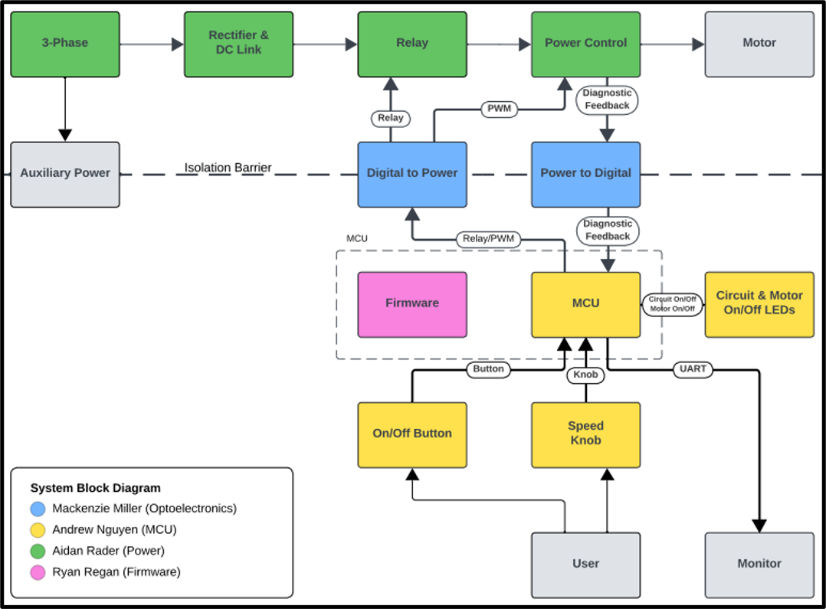

*Figure 2: Block Diagram of System*

## 3.2 Characteristics

### 3.2.1 Functional / Performance Requirements

**3.2.1.1 Speed and Torque Requirement**

The 0.25HP VFD motor shall run up to 1800RPM. The torque requirement for this is 73lb-ft of torque.

**3.2.1.2 Frequency Requirement**

The VFD motor controller shall be able to handle frequencies from 5Hz to 60Hz.

Rationale: American standard frequency for alternating current

**3.2.1.3 Temperature Requirement**

The VFD motor controller shall be able to operate at temperatures ranging from 0°C to 70°C.

Rationale: Commercial temperature rating standards

### 3.2.2 Physical Characteristics

**3.2.2.1 System Components**

The system shall consist of three printed circuit boards (PCBs) connected by wires.

### 3.2.3 Electrical Characteristics

#### 3.2.3.1 Inputs

The presence or absence of any combination of the input signals in accordance with ICD specifications applied in any sequence shall not damage the VFD motor controller, reduce its life expectancy, or cause any malfunction, either when the unit is powered or when it is not.

No sequence of command shall damage the VFD, reduce its life expectancy, or cause any malfunction.

Rationale: By design, should limit the chance of damage or malfunction by user/technician error.

##### 3.2.3.2 Input Voltage Level

The input voltage level for the VFD shall be three phase 120 VAC.

Rationale: VFD specification, Sponsor

##### 3.2.3.3 Input Noise and Ripple

The maximum ripple allowed on the dsPIC33CK is 165mV peak to peak.

Rationale: The specifications from the dsPIC33CK datasheet at 3.3V

##### 3.2.3.4 External Commands

The VFD Motor Control Team shall document all external commands in the appropriate ICD.

Rationale: The ICD will capture all interface details from the low level electrical to the high-level packet format.

##### 3.2.3.5 Visual Output

The VFD shall include a Graphical User Interface that displays output measurements.

Rationale: Provides the ability to see the outputs when VFD is running

#### 3.2.3.6 Connectors

The VFD shall use terminal blocks for all power and signal connections to ensure secure and vibration-resistant connections.

Rationale: Noise must be limited to maintain signal integrity

### 3.2.3.7 Failure Propagation

**3.2.3.7.1 Overtemperature Shutdown**

The VFD shall have a sensor that automatically shuts the system down if the temperature rises above 70 degrees Celsius.

##### 3.2.3.8 Built in Test (BIT)

The VFD shall have an internal subsystem that will generate test signals and evaluate the VFD responses and determine if there is a failure.

**3.2.3.9 Digital to Power Continuity**

The digital to power opto-isolators shall have a voltage of 0V across each component when measuring from input to output.

**3.2.3.10 Power to Digital Continuity**

The power to digital opto-isolators shall have a voltage of 0V across each component when measuring from input to output.

**3.2.3.11 15 VDC to Isolated 15 VDC Conversion**

Power converters shall convert 15 VDC to isolated 15 VDC.

**3.2.3.12 15 VDC to 3.3 VDC Conversion**

Power converters shall convert 15 VDC to 3.3 VDC.

**3.2.3.13 3.3 VDC to Isolated 5 VDC Conversion**

Power converters shall convert 3.3 VDC to isolated 5 VDC.

**3.2.3.14 Low Voltage Auxiliary Power**

System shall convert 15 VDC to isolated 15 VDC , 3.3 VDC, and isolated 5 VDC.

**3.2.3.15 120 VAC to 15 VDC Conversion**

Power converters shall convert 120 VAC to isolated 15 VDC.

**3.2.3.16 120 VAC Auxiliary Power**

System shall convert 120 VAC to 15 VDC, isolated 15 VDC , 3.3 VDC, and isolated 5 VDC.

**3.2.3.17 Relay**

Relay shall toggle the motor with the relay signal.

**3.2.3.18 Relay Signal Isolation**

Digital to power shall convert the relay signal from 3.3 VDC to 5 VDC.

**3.2.3.19 Relay Signal Generation**

MCU shall toggle the relay signal to 3.3 VDC with the button signal.

**3.2.3.20 Firmware Relay Signal Generation**

Dev board shall toggle the relay signal to 3.3 VDC with the button signal.

**3.2.3.21 Button Signal Generation**

Button shall toggle the button signal to 3.3 VDC with a button press.

**3.2.3.22 On/Off Button**

System shall toggle the motor between on and off state with a button press.

**3.2.3.23 120 VAC to 112 VDC Rectification**

Rectifier shall convert 120 VAC to 112 VDC.

**3.2.3.24 120 VAC to 112 VDC Rectification**

Rectifier shall convert 120 VAC to 112 VDC.

**3.2.3.25 Power Control**

Power control shall invert three high and three low 5 VDC PWM signals into three modified sine waves.

**3.2.3.26 PWM Signal Isolation**

Digital to power shall convert three high and three low PWM signals from 3.3 VDC to 5 VDC.

**3.2.3.27 PWM Signal Generation**

MCU shall generate three high and three low 3.3 VDC PWM signals with the knob signal.

**3.2.3.28 Knob Signal Generation**

Rotating potentiometer changes frequency to speed up and slow down motor.

**3.2.3.29 Firmware PWM Signal Generation**

Dev board shall generate three high and three low 3.3 VDC PWM signals with the knob signal.

**3.2.3.30 Firmware Knob Signal Generation**

Rotating dev board potentiometer changes frequency to speed up and slow down motor.

**3.2.3.31 Low Voltage PWM Control**

System shall change the motor speed with the knob signal.

**3.2.3.32 112 VDC PWM Control**

System shall change the motor speed with the knob signal.

**3.2.3.33 Motor On/Off Signal Generation**

MCU shall toggle the motor on/off LED signal to 3.3 VDC with the button signal.

**3.2.3.34 Motor On/Off LED**

System shall toggle the motor on/off LED between on and off states with the motor on/off signal.

**3.2.3.35 System On/Off Signal Generation**

MCU shall toggle the circuit on/off LED signal to 3.3 VDC when the board receives power.

**3.2.3.36 System On/Off LED**

System shall toggle the circuit on/off LED when the board is connected to power with the circuit on/off signal

**3.2.3.37 Firmware Motor On/Off LED Signal Generation**

Firmware shall toggle the dev board's on/off LED signal to 3.3 VDC with the button signal.

**3.2.3.38 Firmware Motor On/Off LED**

Firmware shall toggle the dev board's on/off LED between on and off states with the motor on/off signal.

**3.2.3.39 Firmware System LED Signal Generation**

Firmware shall toggle the dev board's on/off LED signal to 3.3 VDC when the board receives power.

**3.2.3.40 Firmware System LED**

Firmware shall toggle the dev board's on/off LED when the board is connected to power with the circuit on/off signal

**3.2.3.41 Computer Display**

MCU will display diagnostic feedback information to the UART console on a computer running MPLAB X IDE

**3.2.3.42 Diagnostic Feedback Signal Isolation**

Diagnostic feedback circuit shall transport the voltage, current, and temperature signals from across the isolation barrier to the MCU.

**3.2.3.43 Diagnostic Feedback Signal Generation**

Power Control shall generate 60 VDC voltage, current, and temperature feedback signals.

**3.2.3.44 Diagnostic Feedback**

System shall send the voltage, current, and temperature signals to the computer display.

# Appendix A: Acronyms and Abbreviations

BIT Built-In Test

CCA Circuit Card Assembly

EMC Electromagnetic Compatibility

EMI Electromagnetic Interference

EO/IR Electro-optical Infrared

FOR Field of Regard

FOV Field of View

GPS Global Positioning System

GUI Graphical User Interface

Hz Hertz

ICD Interface Control Document

kHz Kilohertz (1,000 Hz)

LCD Liquid Crystal Display

LED Light-emitting Diode

mA Milliamp

MHz Megahertz (1,000,000 Hz)

MTBF Mean Time Between Failure

MTTR Mean Time To Repair

mW Milliwatt

PCB Printed Circuit Board

RMS Root Mean Square

TBD To Be Determined

TTL Transistor-Transistor Logic

USB Universal Serial Bus

VFD Variable Frequency Drive

VME VERSA-Module Europe

# Appendix B: Definition of Terms